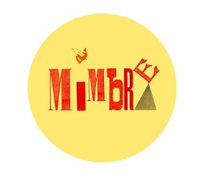
Mimbre’s Visual Story for
The Exploded Circus
This visual story is for children and young adults seeing a performance of The Exploded Circus. It will help you prepare for a new experience and help you become familiar with the show.
If you would like any further information or help please contact Mimbre on info@mimbre.co.uk or you can give us a call on 020 7613 1068.

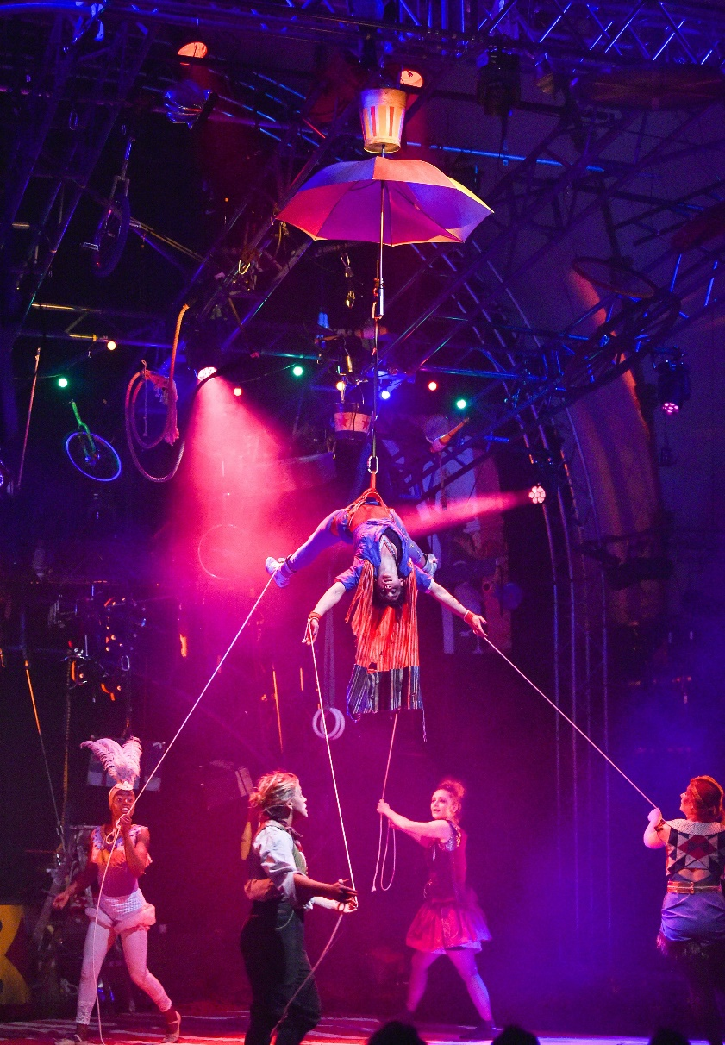
You are coming to see The Exploded Circus. The Exploded Circus is a modern circus show. It has a story and during the story the performers will do tricks like juggling clubs and winding themselves around long pieces of material called silks. The performers have all been practising for a very long time to be able to do this.

The show is 70 minutes long and goes straight through without an interval.

Some performances are ‘relaxed performances’ which means you can go in and out if you need to and make noise. Check with the theatre about which performances are relaxed.

The set is a big blue frame standing on the stage of the theatre. Hanging from the frame are lots of props, costume and bits of furniture that are parts of a circus. They look like they’ve been blown apart in an explosion, but then frozen in space.

At the start, there is a high-pitched sound. The lights gradually dim and then the performers come on.

Characters in the Show

The first person to come on is Antoinette. This is what Antoinette looks like. She looks around in shock and surprise at the exploded circus.

Later on in the show Antoinette will swing and pose on a hoop suspended in the air.

 |  | Antoinette is joined by Janet who is a juggler. Janet is shy and doesn’t realise how good a juggler she is.
 |  | Irene then appears from the top of the frame at the front where she has been hiding since the start of the show. She drops down onto the stage below using two pieces of material.
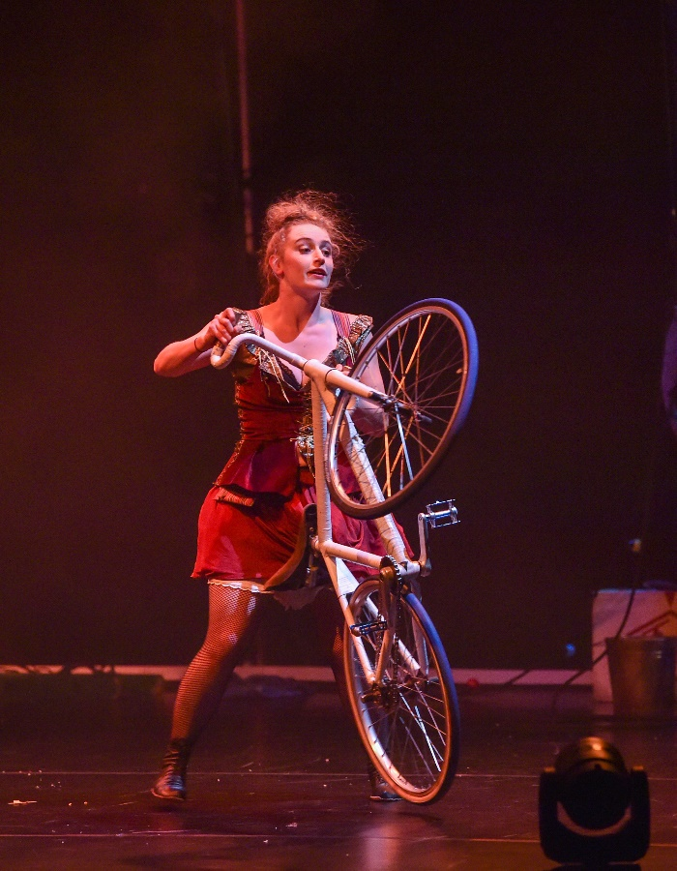 |  | Madame Ringmaster then comes through the audience, saying hello to people as she passes. Later on in the show Madame will perform on a slack rope with lights hung off it and will ride a bicycle.

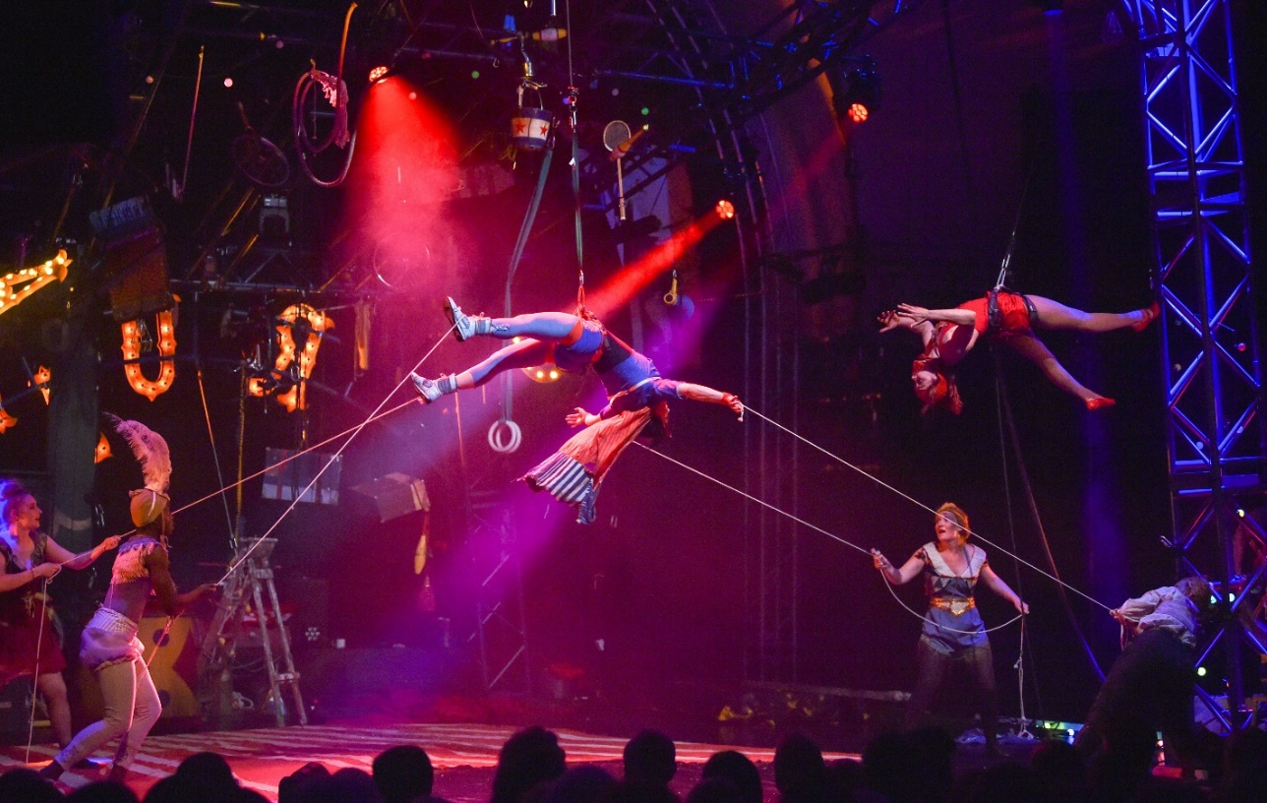
A little later they hear some knocking coming from a cannon at the back of the stage. Inside the cannon is Carol, a human cannonball.

Later on Carol will perform on a long rope hanging from the frame. She will also get lifted into the air by a harness she is wearing.

Finally Baz the clown comes on stage. Later on Baz will leap through hoops and will also perform on the slack rope with Madame.

What happens in the show (contains spoilers!)

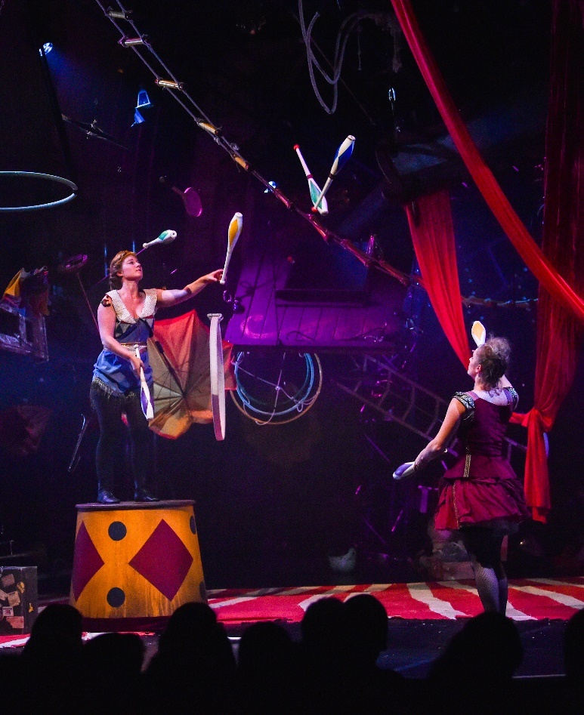
The performers start to work together to tidy up.

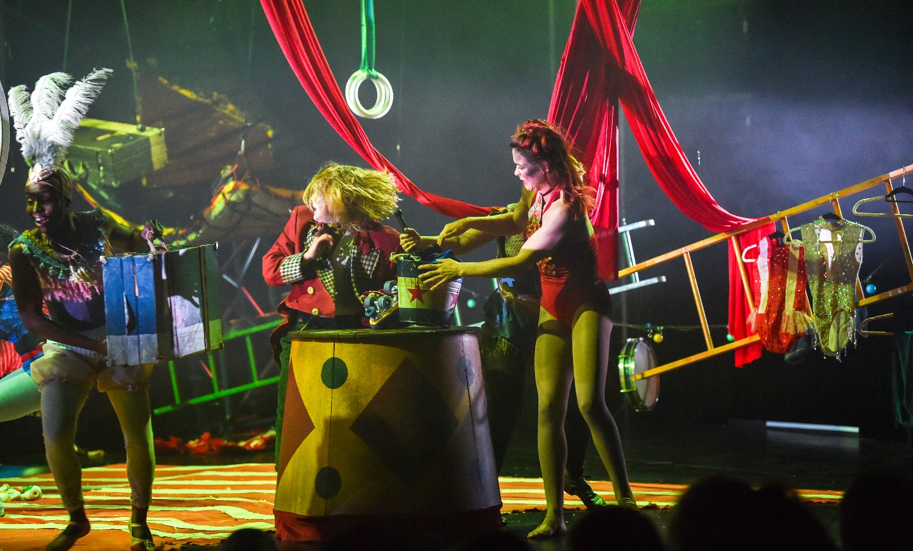
After a little while though they start to argue with each other about who should get to have some of the things.

During this argument a big piece of wood, the top of a doorway with curtains hanging off it, suddenly falls down, but it doesn’t hit anyone.

After this they all go to be on their own. They build little homes hung from the air, apart from Baz the clown who is left on the ground. They are quickly building their homes, and as the noise and action builds and builds, suddenly all the power will go off leaving them in the dark. The noise will get louder and louder and the lights will suddenly go out.

Baz shines a torch at everyone in turn. They are starting to get lonely all on their own. Carol swings on a rope high up on the frame and winds the rope around herself.

Madame has been sitting in the window of the side of an old box office in the air. She passes a cup and teapot to Baz the clown so that Baz can have a cup of tea.

The six performers start to see that they should be working together.
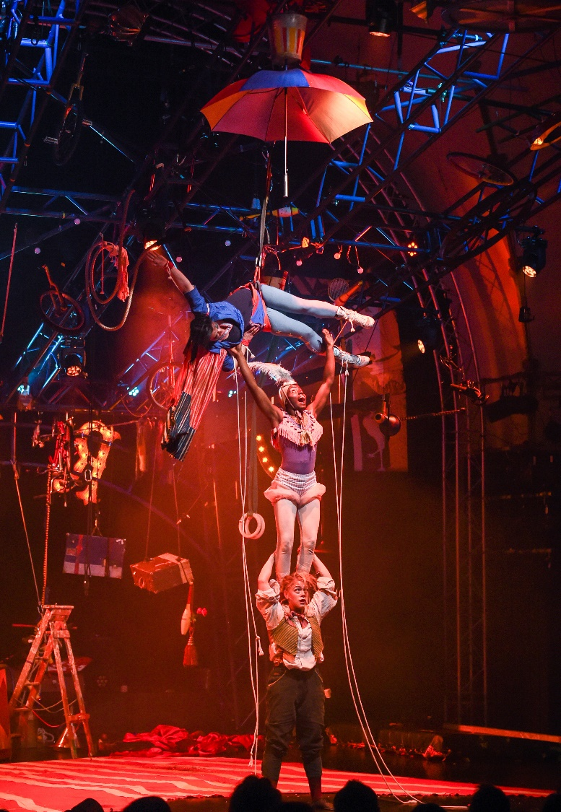

They start to perform together. Baz and Madame both stand on ropes strung across the stage. Baz and Janet juggle together. Carol gets pulled up into the air on a harness while the others pretend that she is flying up in the air and they need to keep her attached to the ground with strings. Madame balances on her bike and cycles around the stage with the other performers all on the bike or holding on to her.

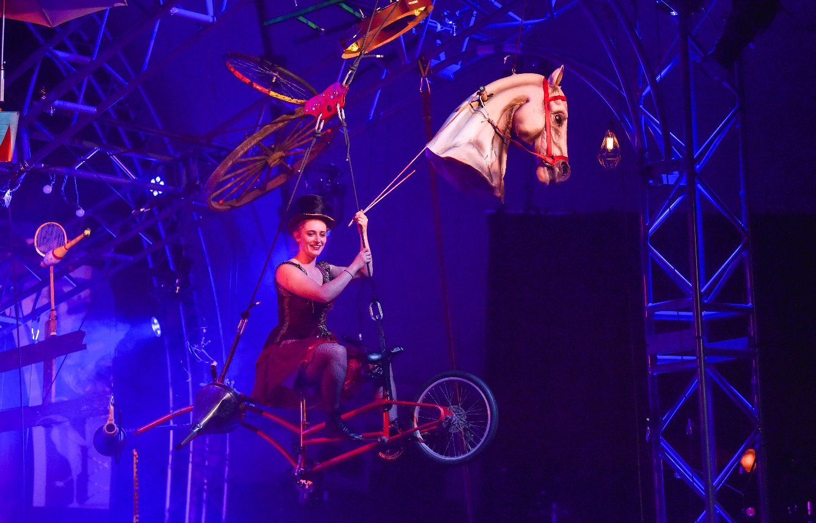

Finally, they hear some sounds that sound like peoples’ voices over the radio and they realise they need to find any other survivors of the explosion. They build a flying machine from the bits of the circus they can find. It has a horse’s head at the front and wings that flap. One bright light comes on behind them and gradually dims.

This is the end of the show. The performers will come down from the flying machine and bow to the audience. You can clap if you like.

Thank you for coming to see The Exploded Circus.

Other access provisions for The Exploded Circus

Introductory notes for blind and partially sighted people can be downloaded from the this webpage: http://theexplodedcircus.co.uk/tour-dates/

Some performances will have touch tours for blind and partially sighted people. Details of these can be found here: http://theexplodedcircus.co.uk/tour-dates/

Some performances will be relaxed performances, where you can go in and out of the auditorium and make noise if you want to. Details of these can also be found here: http://theexplodedcircus.co.uk/tour-dates/

For the access information for each venue please check the venue websites.

If you would like any further information or help please contact Mimbre on info@mimbre.co.uk or you can give us a call on 020 7613 1068.

Many thanks to Touretteshero for their help in producing this document.
Photograph credit: Simon Dack (Vervate Photography)

